**МІНІСТЕРСТВО ОСВІТИ І НАУКИ УКРАЇНИ**

**НАЦІОНАЛЬНОМУ УНІВЕРСИТЕТІ “ЛЬВІВСЬКА ПОЛІТЕХНІКА”**

**Кафедра систем штучного інтелекту**

**Лабораторна робота №2**

з дисципліни

«Організація баз даних та знань»

**Виконав:**

студент групи КН-208

Яковлев Валерій

**Викладач:**

Мельникова Н.І.

Львів – 2019 р.

Мета роботи: Побудувати даталогічну модель бази даних; визначити типи,  
розмірності та обмеження полів; визначити обмеження таблиць; розробити SQL запити для  
створення спроектованих таблиць.

На основі діаграми побудувати Базу Даних. 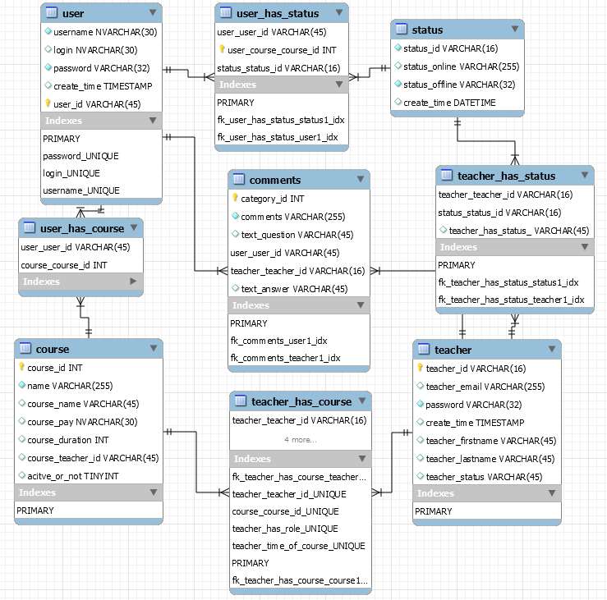

Створив базу даних



Створив таблицю User

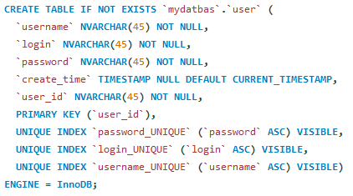

Cтворив таблицю Teacher

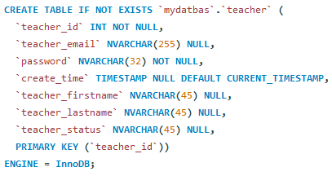

Cтворив таблицю Course

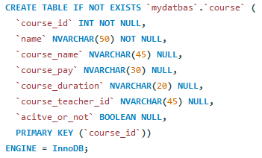

Cтворив таблицю Comments

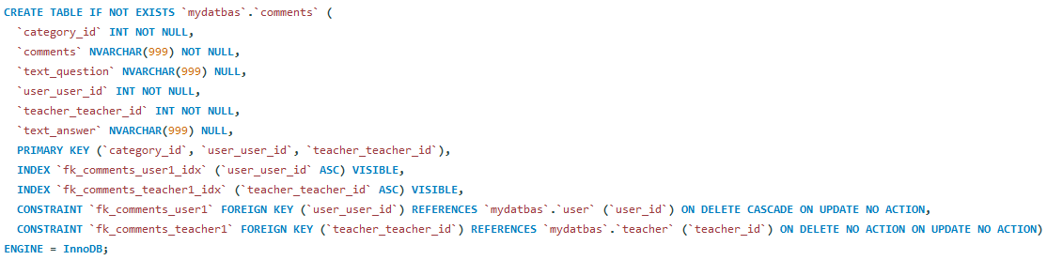

Cтворив таблицю Status

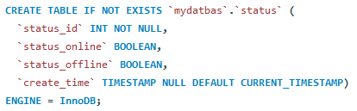

**Код запиту:**

IF EXISTS(SELECT * FROM sys.databases where name = 'Computer_courses')

DROP DATABASE Computer_courses;

create database if not exists root;

CREATE SCHEMA IF NOT EXISTS `mydatbas` DEFAULT CHARACTER SET utf8 COLLATE utf8_bin ;

USE `mydatbas`;

CREATE TABLE IF NOT EXISTS `mydatbas`.`comments` (

`category_id` INT NOT NULL,

`comments` NVARCHAR(999) NOT NULL,

`text_question` NVARCHAR(999) NULL,

`user_user_id` INT NOT NULL,

`teacher_teacher_id` INT NOT NULL,

`text_answer` NVARCHAR(999) NULL,

PRIMARY KEY (`category_id`, `user_user_id`, `teacher_teacher_id`),

INDEX `fk_comments_user1_idx` (`user_user_id` ASC) VISIBLE,

INDEX `fk_comments_teacher1_idx` (`teacher_teacher_id` ASC) VISIBLE,

CONSTRAINT `fk_comments_user1` FOREIGN KEY (`user_user_id`) REFERENCES `mydatbas`.`user` (`user_id`) ON DELETE CASCADE ON UPDATE NO ACTION,

CONSTRAINT `fk_comments_teacher1` FOREIGN KEY (`teacher_teacher_id`) REFERENCES `mydatbas`.`teacher` (`teacher_id`) ON DELETE NO ACTION ON UPDATE NO ACTION)

ENGINE = InnoDB;

CREATE TABLE IF NOT EXISTS `mydatbas`.`course` (

`course_id` INT NOT NULL,

`name` NVARCHAR(50) NOT NULL,

`course_name` NVARCHAR(45) NULL,

`course_pay` NVARCHAR(30) NULL,

`course_duration` NVARCHAR(20) NULL,

`course_teacher_id` NVARCHAR(45) NULL,

`acitve_or_not` BOOLEAN NULL,

PRIMARY KEY (`course_id`))

ENGINE = InnoDB;

CREATE TABLE IF NOT EXISTS `mydatbas`.`status` (

`status_id` INT NOT NULL,

`status_online` BOOLEAN,

`status_offline` BOOLEAN,

`create_time` TIMESTAMP NULL DEFAULT CURRENT_TIMESTAMP)

ENGINE = InnoDB;

CREATE TABLE IF NOT EXISTS `mydatbas`.`teacher` (

`teacher_id` INT NOT NULL,

`teacher_email` NVARCHAR(255) NULL,

`password` NVARCHAR(32) NOT NULL,

`create_time` TIMESTAMP NULL DEFAULT CURRENT_TIMESTAMP,

`teacher_firstname` NVARCHAR(45) NULL,

`teacher_lastname` NVARCHAR(45) NULL,

`teacher_status` NVARCHAR(45) NULL,

PRIMARY KEY (`teacher_id`))

ENGINE = InnoDB;

CREATE TABLE IF NOT EXISTS `mydatbas`.`teacher_has_course` (

`teacher_teacher_id` INT NOT NULL,

`course_course_id` INT NOT NULL,

`teacher_has_role` NVARCHAR(45) NULL,

`teacher_time_of_course` DATETIME(24.05.2019) NULL,

`course_course_id1` INT NOT NULL,

INDEX `fk_teacher_has_course_teacher1_idx` (`teacher_teacher_id` ASC) VISIBLE,

UNIQUE INDEX `teacher_teacher_id_UNIQUE` (`teacher_teacher_id` ASC) VISIBLE,

UNIQUE INDEX `course_course_id_UNIQUE` (`course_course_id` ASC) VISIBLE,

UNIQUE INDEX `teacher_has_role_UNIQUE` (`teacher_has_role` ASC) VISIBLE,

UNIQUE INDEX `teacher_time_of_course_UNIQUE` (`teacher_time_of_course` ASC) VISIBLE,

PRIMARY KEY (`teacher_teacher_id`, `course_course_id1`),

INDEX `fk_teacher_has_course_course1_idx` (`course_course_id1` ASC) VISIBLE,

CONSTRAINT `fk_teacher_has_course_teacher1` FOREIGN KEY (`teacher_teacher_id`) REFERENCES `mydatbas`.`teacher` (`teacher_id`) ON DELETE NO ACTION ON UPDATE NO ACTION,

CONSTRAINT `fk_teacher_has_course_course1` FOREIGN KEY (`course_course_id1`) REFERENCES `mydatbas`.`course` (`course_id`) ON DELETE NO ACTION ON UPDATE NO ACTION)

ENGINE = InnoDB;

CREATE TABLE IF NOT EXISTS `mydatbas`.`teacher_has_status` (

`teacher_teacher_id` INT NOT NULL,

`status_status_id` INT NOT NULL,

`teacher_has_status_` BOOLEAN NOT NULL,

PRIMARY KEY (`teacher_teacher_id`, `status_status_id`),

INDEX `fk_teacher_has_status_status1_idx` (`status_status_id` ASC) VISIBLE,

INDEX `fk_teacher_has_status_teacher1_idx` (`teacher_teacher_id` ASC) VISIBLE,

CONSTRAINT `fk_teacher_has_status_teacher1` FOREIGN KEY (`teacher_teacher_id`) REFERENCES `mydatbas`.`teacher` (`teacher_id`) ON DELETE NO ACTION ON UPDATE NO ACTION,

CONSTRAINT `fk_teacher_has_status_status1` FOREIGN KEY (`status_status_id`) REFERENCES `mydatbas`.`status` (`status_id`) ON DELETE NO ACTION ON UPDATE NO ACTION)

ENGINE = InnoDB;

CREATE TABLE IF NOT EXISTS `mydatbas`.`user` (

`username` NVARCHAR(45) NOT NULL,

`login` NVARCHAR(45) NOT NULL,

`password` NVARCHAR(45) NOT NULL,

`create_time` TIMESTAMP NULL DEFAULT CURRENT_TIMESTAMP,

`user_id` NVARCHAR(45) NOT NULL,

PRIMARY KEY (`user_id`),

UNIQUE INDEX `password_UNIQUE` (`password` ASC) VISIBLE,

UNIQUE INDEX `login_UNIQUE` (`login` ASC) VISIBLE,

UNIQUE INDEX `username_UNIQUE` (`username` ASC) VISIBLE)

ENGINE = InnoDB;

CREATE TABLE IF NOT EXISTS `mydatbas`.`user_has_course` (

`user_user_id` NVARCHAR(45) NOT NULL,

`course_course_id` INT NOT NULL,

PRIMARY KEY (`user_user_id`, `course_course_id`),

INDEX `fk_user_has_course_course1_idx` (`course_course_id` ASC) VISIBLE,

INDEX `fk_user_has_course_user1_idx` (`user_user_id` ASC) VISIBLE,

CONSTRAINT `fk_user_has_course_user1` FOREIGN KEY (`user_user_id`) REFERENCES `mydatbas`.`user` (`user_id`) ON DELETE NO ACTION ON UPDATE NO ACTION,

CONSTRAINT `fk_user_has_course_course1` FOREIGN KEY (`course_course_id`) REFERENCES `mydatbas`.`course` (`course_id`) ON DELETE NO ACTION ON UPDATE NO ACTION)

ENGINE = InnoDB;

CREATE TABLE IF NOT EXISTS `mydatbas`.`user_has_status` (

`user_user_id` NVARCHAR(45) NOT NULL,

`user_course_course_id` NVARCHAR(45) NOT NULL,

`status_status_id` NVARCHAR(16) NOT NULL,

PRIMARY KEY (`user_user_id`, `user_course_course_id`, `status_status_id`),

INDEX `fk_user_has_status_status1_idx` (`status_status_id` ASC) VISIBLE,

INDEX `fk_user_has_status_user1_idx` (`user_user_id` ASC, `user_course_course_id` ASC) VISIBLE,

CONSTRAINT `fk_user_has_status_user1` FOREIGN KEY (`user_user_id`) REFERENCES `mydatbas`.`user` (`user_id`) ON DELETE NO ACTION ON UPDATE NO ACTION,

CONSTRAINT `fk_user_has_status_status1` FOREIGN KEY (`status_status_id`) REFERENCES `mydatbas`.`status` (`status_id`) ON DELETE NO ACTION ON UPDATE NO ACTION)

ENGINE = InnoDB;